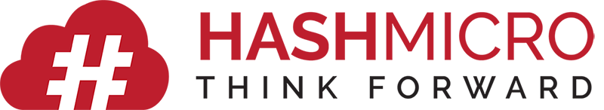

Employee Development Plan Template
A forward-looking plan to build skills, close capability gaps, and support career growth.
Employee / Meeting Information
Employee Name: |  | Manager Name:
Job Title / Level: |  | Department:
Plan Start Date: |  | Plan End Date:

Skills & Capability Gap Analysis
# | Skill / Competency | Current Level (1–5) | Target Level (1–5) | Gap / Priority | Urgency (H/M/L) | Review By | Notes
1
2
3
4
5
6
7
8
9
10

Support & Accountability
Resources / Budget Available:
Manager's Commitment & Support:
Employee's Commitment Statement:
Overall Progress Rating at Plan End (1–5):
Key Outcomes Achieved:
Recommended Next Development Focus:

Development Activities Plan
# | Development Activity | Type | Target Skill | Success Measure | Start | End | Status

Milestones & Progress Check-Ins
Milestone | Target Date | Achieved Date | Evidence / Notes | Next Step

Rating Scale Legend
5 – Outstanding | Consistently exceeds all expectations; role model performance.
4 – Exceeds Expectations | Frequently surpasses targets and requirements.
3 – Meets Expectations | Consistently fulfills all job requirements.
2 – Needs Improvement | Partially meets expectations; development required.
1 – Unsatisfactory | Fails to meet basic requirements; immediate action needed.

Sign-Off & Acknowledgement
Employee Signature: | Date: | Manager Signature: | Date: | HR Signature: | Date:

